|  |  |
| --- | --- |
| No. of Pages | **3** |
| No. of Questions | 4 |

**Department of Computer Science and Engineering**

**FINAL EXAMINATION SUMMER 2013**

**CSE490/EEE453: WAN Routing and Technologies**

**Total Marks:60 Time Allowed: 70 minutes**

* Answer ALL FOUR **(4)** questions.
* Figure in bracket [] next to each question indicates marks for that question.

## Question No. 1

* 1. In a LAN installing more routers will make the network more efficient, true or false. Justify your answer. [3 marks]

1. How do you know whether a switch has passed or failed the POST? [2 marks]
2. In switches that have the AUTO-MDIX feature is helpful, why? [2 marks]

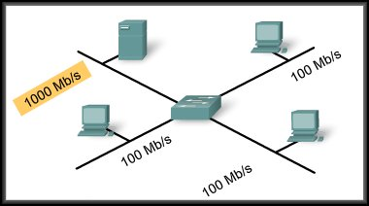

**Figure No. 1**

1. In the above switched network shown in figure no. 1, what type of memory buffering should be used and why? [4 marks]

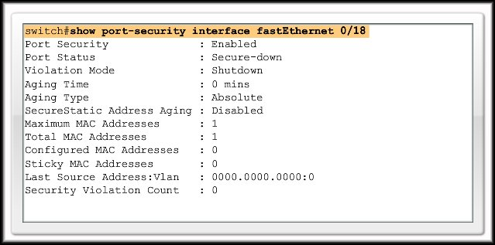

**Figure No. 2**

###### Refer to the output shown in figure no. 2, a PC is attached to port fa0/18. Somebody comes in and disconnects the PC and attaches his laptop to the port fa0/18. What will happen if that person tries to access the network? Explain your answer. [4 marks]

###### Question No. 2

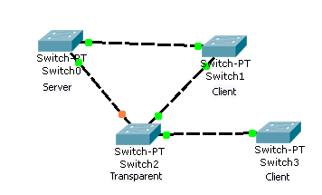

**Figure No. 3**

1. Refer to the figure no. 3 above; the network administrator has just added VLAN 10, 20 in Switch0 and VLAN 10, 30 in Switch 2. What actions will occur after that? [4 marks]
2. Is a transparent switch able to obtain VLAN information when it reboots? [3 marks]
3. What triggers a VTP server switch to send a summary advertisement and subset advertisement? [4 marks]
4. State some common problems associated with Inter VLAN routing? [4 marks]

Question No. 3

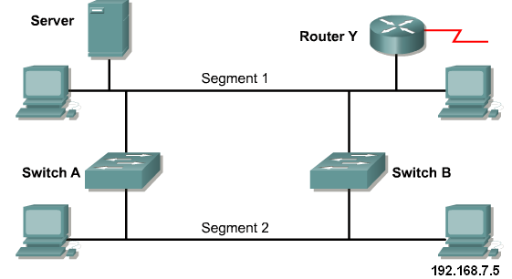

**Figure No. 4**

1. PC with the IP address 192.168.7.5, sends a broadcast packet in the network shown in figure no. 4. How will the switches handle the packet? Assume STP is enabled. [4 marks]
2. How long can it take for a network using spanning tree topology to converge again after a topology change? [3 marks]

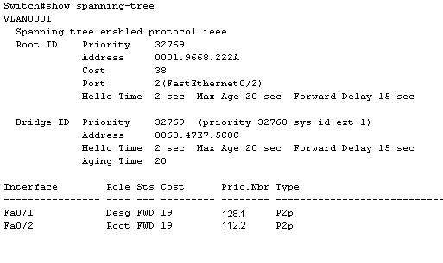

**Figure No. 5**

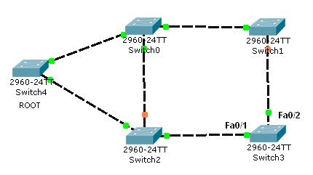

1. Refer to the exhibit above in figure no. 5. Identify Switch 3’s root port. Also explain why it becomes the root port? [4 marks]

1. What happens if you have some switches running STP and some running RSTP? [2 marks]
2. If a port is configured as a RSTP edge port, what type of device can we connect to that port? [2 marks]

## Question No. 4

1. You configure interface Fa0/1 as follows:

SW1(config-if)#**switchport mode trunk**

Which is the native VLAN, and which VLANs can this interface handle? [3 marks]

1. A switched network uses dynamic VLAN assignment. So when a PC with the MAC 1A23-BC78-E865-5487 is attached to port fa0/3, the PC will be considered under which VLAN? [4 marks]
2. What is tagging? What does a switch port on a trunk link do if it receives a frame without a tag? [4 marks]



**Figure No. 6**

1. Refer to the exhibit shown in figure no. 6. The network administrator has created a new VLAN on Switch1 and added host C and host D. The administrator has properly configured switch interfaces FastEthernet0/13 through FastEthernet0/14 to be members of the new VLAN. However, after the network administrator completed the configuration, host A could communicate with host B, but host A could not communicate with host C or host D. Which commands are required to resolve this problem?

[4 marks]

##### THE END